Zebrafish behavior identification methods

A summary of our analysis methods to identify behaviors given tracking data on pairs of zebrafish

**Raghuveer Parthasarathy**

Based on methods from Estelle Trieu, Laura Desban, and Raghuveer Parthasarathy

Begun May 15, 2023

Last modified August 23, 2025

# Inputs

Movies: 10 minutes, 15000 frames, 25 fps

Tracking output from “ZebraZoom” software. Ideally, it identifies two fish in each frame. For each fish in each frame, returns the head position, 10 body positions (one of which is the head), the heading angle, and the tail angle.

Image scale: mean ± std = 56.7 ± 0.6 um/px. Listed for each experiment in the fifth column of ArenaCenters_SocPref_3456.xslx

Quickly assessing overall fish length: about 7 mm (120 px at 57 um/px).

# General approach

Through human observation of movies of zebrafish pairs we identified common, interpretable behavioral motifs including circling, tail-rubbing, perpendicular orientation, and contact. We devised geometric criteria and parameter ranges that describe each behavior and then encoded these in software to automate their identification in tracking datasets.

[Accuracy estimation – redo any of them?]

[Same parameters used for different experimental conditions, so comparison is possible]

It is in principle possible to [fully automate; problems with this alternative approach.]

# Notation:

**dHH:** distance vector between the head positions of the two fish; magnitude dHH.

**dC:** closest distance between two fish, considering any pair of body points.

**Θi:** The heading angle of fish i (i = 1, 2), i.e. the angle relative to the zero angle of the lab coordinate system.

**ni:** the heading vector of fish i (I = 1, 2)

# General Single-Fish Characterizations

The following are not identified as discrete events, but rather characterize properties of each individual fish trajectory.

## Moving

We note the speed of each fish, mm/s, calculated from the frame-to-frame head displacement. From this, we can define an “is moving” criterion, true if the speed exceeds some threshold speed.

**Parameters:**

motion_speed_threshold = 9 mm/s

## Edge proximity

Indicating proximity to the edge, closer than “edge_proximity_threshold_mm”. No behaviors are rejected based on this parameter. (There is a separate “edge_rejection_threshold_mm” parameter for rejecting behavior counts.)

**Parameters:**

edge_proximity_threshold_mm = 5 mm

# Specific Two-Fish Behaviors

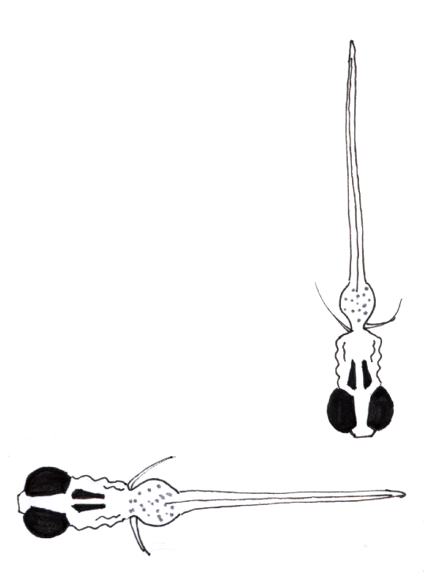

## Perpendicular Orientation

The two fish are close to each other and oriented perpendicularly over some time interval. Specifically, |cos(Θ1 – Θ2)| < cosΘthreshold_perp and dC < perp_maxDistance for all frames in a window of length perp_windowsize.

**Subcategories:** The configuration can be such that none, one, or both of the fish are facing the other fish. These are distinguished based on the angles φ between the heading vector of a given fish *j*, **nj**, and the vectors from its head to each body position of the other fish, **dHB****,jk**. We consider that fish *j* can “see” fish *k* if cos(φ) > cosΘseeing for *any* of the angles φ. In addition, for the case in which one fish “sees” the other, we identify whether the larger or the smaller fish is the one that “sees.”

**Parameters:**

perp_windowsize = 2 frames (80 ms)

cosΘthreshold_perp = 0.26 (corresponding to ± 15 degrees)

cosΘseeing = 0.5 (corresponding to ± 60 degrees)

perp_maxDistance = 12 mm (approx. 1.5 fish lengths)

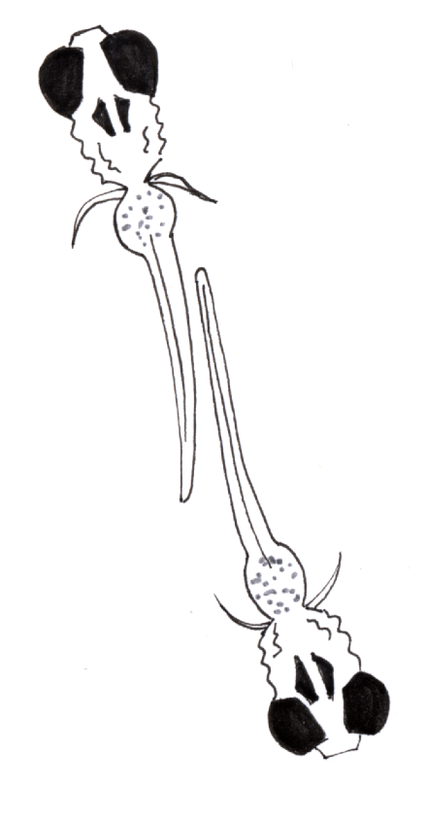

## Tail Rubbing

The two fish are oriented roughly antiparallel with their tails in close proximity over some time interval. Specifically, cos(Θ1 – Θ2) < cosΘAntiParallel for all frames in a window of length Nframes, at least two of the four most posterior tail positions are within tailrub_maxTailDist of each other, and the head-head distance **d** < tailrub_maxHeadDist.

**Parameters:**

Nframes = 4 frames (160 ms)

cosΘAntiParallel = -0.8 (corresponding to 180 ± 37 degrees)

tailrub_maxTailDist = 2.0 mm (approx. 35 px)

tailrub_maxHeadDist = 12.5 mm (approx. 220 px)

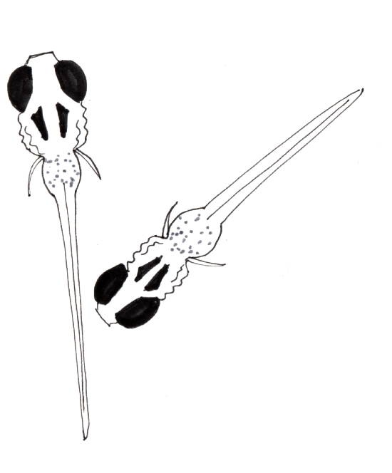

## Contact

The two fish are very close to each other. This need only persist for a single frame. Specifically, the minimum distance between the two fish, considering any pair of the ten markers on each fish, is less than a threshold value, dthreshold_contact.

Subcategories: **Head-body contact,** defined such that the distance between the head of one fish and any point on the body of the other is less than contact_distance_threshold.

For the subset of head-body contact cases in which only *one* fish has head-body distance below threshold, record whether it’s the larger or smaller fish.

**Inferred contact.** Close proximity can lead to tracking failures in which the tracking software does not resolve two fish. Infer the existence of contact events (**inferred contact**) by either of the following occurring: (i) Tracking failures that are preceded by the inter-fish (head-head) distance being less than contact_inferred_distance_threshold *and* the distance monotonically decreasing over contact_inferred_window frames. The last good frame before bad tracking is considered an inferred contact frame. (ii) Bad tracking frames that are preceded and followed by contact events, if the total distance the fish have moved is less than Nfish x contact_distance_threshold.

The “contact_any” category includes contact (body-body or head-body) and “inferred” contacts. Because of inferred contacts, this list of frames can include bad tracking frames, unlike other behaviors.

**Parameters:**

contact_distance_threshold = 2.5 mm (approx. 44 px)

contact_inferred_distance_threshold = 3.5 mm (approx. 62 px)

contact_inferred_window = 3 frames (120 ms)

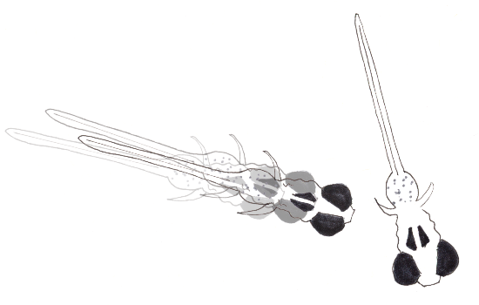

## Approaching

One fish is approaching the other. Specifically: over some number of frame intervals, the speed is greater than some threshold speed, the distance between the fish is decreasing, and the angle Θ between the approaching fish’s heading and the vector to the closest point on the other fish is less than some threshold (implemented as cos(Θ) > cosΘapproach)).

**Parameters:**

speed_threshold = 20 mm/s (approx. 15 px/frame)

min_frame_duration = 2 frames

cosΘapproach = 0.5 (60 degrees)

## Fleeing

One fish is fleeing from the other. Specifically: over some number of frame intervals, the speed is greater than some threshold speed, the distance between the fish is increasing, and, using the same notation and threshold as “approaching,” cos(Θ) < cosΘapproach). Not that the angle criterion doesn’t require moving directly away (which would be cos(Θ) < -1 × cosΘapproach); often fleeing fish take a perpendicular path.

**Parameters:**

speed_threshold = 20 mm/s (approx. 15 px/frame)

min_frame_duration = 2 frames

cosΘapproach = 0.5 (60 degrees)

## Proximity

The closest distance between two fish is less than some threshold distance.

**Parameters:**

proximity_threshold_mm = 7 mm (approx. 1 body length)

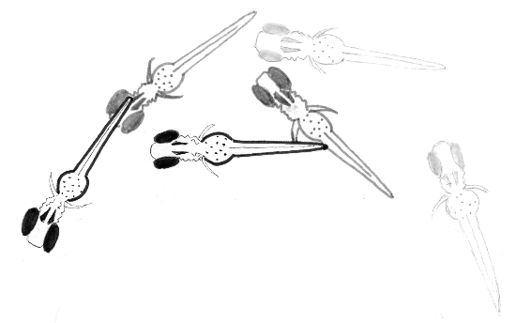

## Maintaining Proximity

Two fish maintain proximity. At least one fish must be moving, and we allow short gaps in motion. The motion and proximity threshold parameters are the same as used for other behaviors.

but requiring an overall minimal duration for the maintenance behavior.

**Parameters:**

motion_speed_threshold = 9 mm/s

proximity_threshold_mm = 7 mm (approx. 1 body length)

max_motion_gap_s = 0.5 s (12.5 frames at 25 fps)

min_proximity_duration_s = 0.0 s

# Behaviors (Single Fish)

## Bending (general)

Calculate a bend angle Θbend as follows: Consider all points from the midpoint to the anterior-most point; fit a line to these. Similarly fit a line for points from the midpoint to the posterior-most point. Determine the angle between these best-fit lines. Denote the supplement of this (i.e. π – this angle) as the bend angle, so that 0 is a straight fish. Use the bend angle to categories various bends (see below).

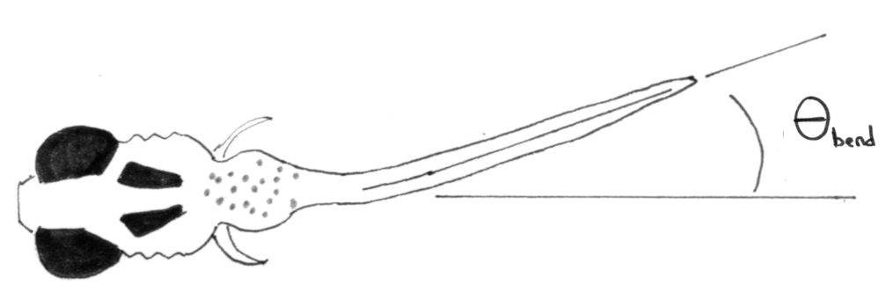

## J-Bend, Routine turn, C-Bend

Categorize turns as the bend angle being between:

(bendmin, bendJmax] : J-bend

(bendJmax, bendCmin] : R-bend (routine turn)

(bendCmin, π] : C-bend

Consider contiguous blocks of frames with bending angle > bendmin. Assign the bending behavior for the whole block as the type (J, R, C) corresponding to the maximum bending angle of that sequence

**Parameters:**

bendmin = 10 degrees (0.175 radians)

bendJmax = 50 degrees (0.873 radians)

bendCmin = 100 degrees (1.75 radians)

C-Bends

# General Two-Fish Characterizations

The following are not identified as discrete events, but rather characterize overall properties of pair trajectories.

## Inter-fish distance

Mean inter-fish distance, calculated both as the head-to-head distance and the distance between closest points. For the mean, ignore bad-tracking frames. (Pixels).

## Difference in fish lengths

Mean difference between inferred lengths of fish, ignoring bad-tracking frames. (Pixels).

## Cross-correlation of heading angles

Calculate the normalized cross-correlation coefficient of the heading angles of the two fish (Θ1, Θ2) over a sliding window of frames *W*:

$$Xcorr\left(frame i\right)= \frac{\sum_{j=0}^{W}{\left(θ_{1}(i+j)-\overline{θ_{1}}\right)\left(θ_{2}(i+j)-\overline{θ_{2}}\right)}}{\sqrt{\sum_{j=0}^{W}{{\left(θ_{1}(i+j)-\overline{θ_{1}}\right)}^{2}} \sum_{j=0}^{W}{{\left(θ_{2}(i+j)-\overline{θ_{2}}\right)}^{2}}}}$$

If the two fish maintain the same relative angles, Xcorr = 1; if they are uncorrelated, Xcorr = 0.

Calculate the average, standard deviation, and skew of all the cross-correlation values over all frames, excluding bad frames. (Exclude if *any* bad frames are in the window.) Of these, the average (mean) seems most relevant; save this in the output CSV file.

**Parameters:**

W = 25 frames (1 second)

## Relative orientation

Angle between heading and head-to-head vector, for each fish (**d**12 = vector from Fish 1 to Fish 2; calculate φ1 = Angle(Θ1, **d**12) and φ2 = Angle(Θ2, **d**21), where Θi is the heading angle for Fish *i*. These φ are the same as the “relative orientations” Θ in O’Shaughnessy 2024. Range: [0, π]. Note that φ*i*< π /2 corresponds to Fish *i* facing towards the other fish.

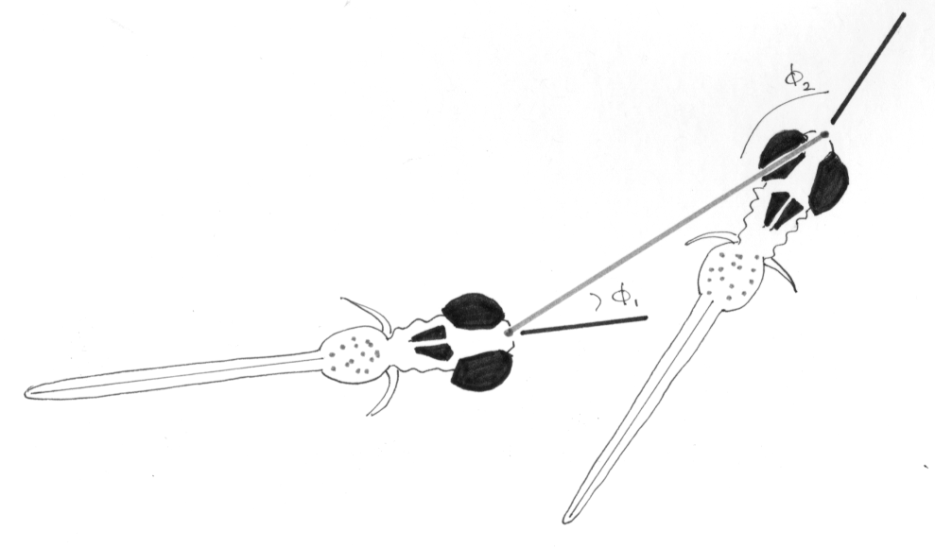

## Relative heading

Difference in heading angle between two fish, |Θ2 – Θ1|, range [0, π].

# Other processing

**Proximity to the dish edge.** Data from frames in which either fish is within a threshold distance dedge from the edge of the circular arena are discarded.

**Tracking failures.** Data from frames in which the tracking software fails to detect one or both of the two fish are discarded, though they may be used to infer contact events (see “Contact”). Specifically, tracking is considered “bad” if one or more body positions for either fish are recorded as zero. In addition, tracking is “bad” if the distance between positions 1 and 2 (head-body) is more than 3 times the mean distance between positions j and j+1 for j = 2 to 9.

**Parameters:**

dedge = 5 mm

# Deleted Criteria

## J-Bends

A fish body shows a J-shaped bend, with a straight anterior half and a curved posterior. This is assessed specifically by (i) the straightness of the anterior points: principal component analysis of the (x, y) values of body-points 1 through 5 has at least rAP of the total variance, (ii) the angle of the last segment φN relative to the heading angle Θ is near ± 90 degrees: |cos(φN – Θ)| < JbendcosThetaN , and (iii) the angle of the second-to-last segment φN-1 relative to the heading angle Θ is large: |cos(φN-1 – Θ)| < JbendcosThetaNm1 .

**Parameters:**

rAP = 0.98

JbendcosThetaN = 0.34 (90 ± 20 degrees)

JbendcosThetaNm1 = 0.7 (90 ± 45 degrees)

## C-Bends

A fish body shows a sharp bend. This is assessed by the ratio of the head-to-tail-end distance / the overall fish length (sum of segments), with a bending “event” identified as ratio < Cbend_threshold. Use as the threshold the ratio of the diameter to semi-circle arc length of a circle, i.e. an opening angle of 180 degrees, i.e. the fish body is as curved as a half-circle. For 180 degrees, this ratio is 2/π = 0.637.

**Parameters:**

Cbend_threshold = 2/π = 0.637

# Deleted Behaviors

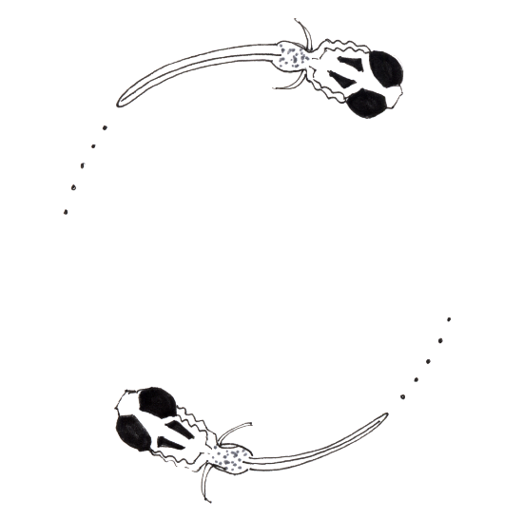

## Circling

[Abandoned July 2023]

Identify circling by fitting a circle to the head positions of both fish over some window of frames, circle_windowsize, and assessing whether the following criteria are met over all window frames:

1. the two fish are close to each other; specifically d < circle_distance_threshold .
2. the two fish are moving; specifically RMS displacement per frame < motion_threshold .
3. the two fish have a antiparallel orientation; specifically cos(Θ1 – Θ2) < cos_theta_AP_threshold.
4. their trajectories are well-fit by a circle; specifically the root-mean-squared deviation of the head positions to the best-fit circle must be less than circle_fit_threshold x *R*, where *R* is the circle radius.
5. the radius *R* of the best-fit circle should be less than the mean distance between the heads of the fish over the frame window
6. the fish heading vectors should be tangent to the best-fit circle; specifically |cos(Θi)| < cos_theta_tangent_threshold, for both fish i = 1,2, where Θi is the angle between the fish heading vector and the radial vector.

**Parameters:**

circle_windowsize = 25 frames (1 s)

motion_threshold = 2 px (113 μm)

cos_theta_AP_threshold = –0.7 (corresponding to 180 ± 45 degrees); was –0.9 (180 ± 26 degrees)

circle_fit_threshold = 0.25

cos_theta_tangent_threshold = 0.34 (corresponding to ± 20 degrees)

circle_distance_threshold = 240 px (13.6 mm)